American University of Beirut

Modeling Data in Excel

Name: Freddy Vartabedian
ID: 201203799

Section 5

Wednesday, December 14, 2011

I- Introduction
A-Motivation:
Perceiving the flexibility and importance of spreadsheets in modeling data, as the one provided by Excel.

B-Objectives:

- Calculating the volume and the area of a cone for different values of its radius using spreadsheets.

- Modeling the results obtained in the form of a graph.

- Using Math type to write the mathematical cone equations.

C-Overview:
In this lab assignment we need to calculate the volume and area of a cone while being able to change some input values such as radius and height. This can be done using different methods including the use of a programming language, spreadsheets… But, in what follows we are using spreadsheets, because that it requires fewer skills than programming.
Outline Page
- Introduction 2
- Background 3
- Cone Equations 4
- Modeling Process 5
- Tools 7
- Results 10
- Conclusion 12
- References 13
- Appendices 14

II- Background:
Definition of a cone:
“A cone is a solid figure generated by a line, one end of which is fixed and the other end describes a closed curve in a plane. A circular cone is a solid figure whose base is a circle and whose lateral surface area (i.e. curved surface area) tapers uniformly to a point: which is called the vertex or apex. The axis of the cone is a straight line drawn from the vertex to the center of the base. A right circular cone is a cone whose base is a circle and whose axis is perpendicular to the base. Such a cone can also be described as solid formed by a right triangle rotated about one of its sides as an axis; it may, therefore, be called a cone of revolution. The figure below represents a right circular cone.”
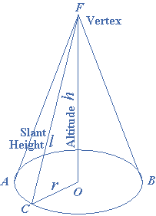

For simplicity, we are going to deal with right circular cones.

III -Cone Equations:
The volume of a cone is:
V = $\frac{1 }{3 }B.h$
Where B is the base area and h is the height. If the base is circular, then:
$$B=π.r^{2}$$
Where r is the radius of the base.
The volume equation becomes:
V = $\frac{1 }{3 }π.r^{2}.h$
The surface area S, not including the base, is given by the following formula:
$$S= π.r\sqrt{r^{2}+ h^{2}}$$
The total surface area T becomes:
$$T= π.r\sqrt{r^{2}+ h^{2}}+ π.r^{2}$$

IV -Model Development:
The Microsoft Excel spreadsheet should be organized to be easily read by others.
The left side of the table is used to enter the project’s title and input variables such as radius and height.
The figure below is an example:
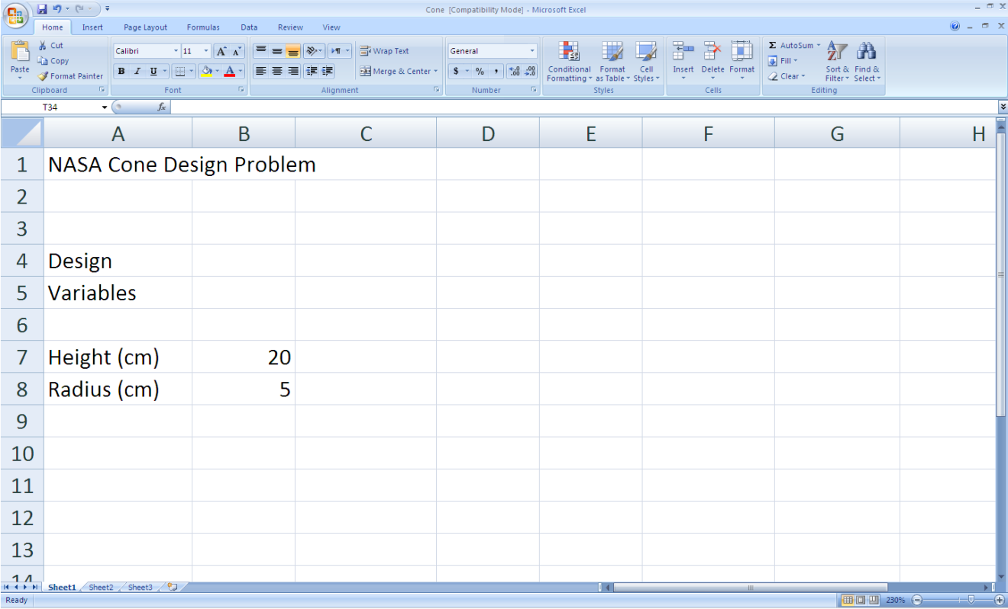

The right side is used for the outputs mainly the volume and area of the cone.
The formulas should be entered as follows:
For Volume:
“=(1/3)*pi()*B7*F7^2”
For Area:
“=pi()*F7*(B7^2+F7^2)^0.5”

The Spreadsheet at this stage:

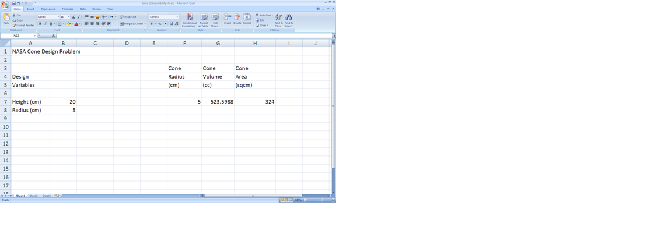

Changing the input variables leads to change in cells G7 and H7 representing the volume and area respectively.
The height of the cone is fixed: 20cm. The radius is variable. When we enter data, depending on the radius, we can examine the volume and area.

V- Excel Tools:

1-Formula Copying Feature:

Excels formula copying feature has an updating capability which will enter the appropriate formula with each value. Instead we use relative and absolute addresses. Since Excel updates all relative addresses and not just the one we choose, we need to assign our value an absolute address in the formula. This is done by placing $ in front of the letter corresponding to the column and in front of the number of the row in the area and volume formulas. For example, if we expand the formula:
B1=A1+A2 to B2 and B3 using the “fill handle”, then B2=A2+A3, B3=A3+A4.
However, if we want to increment A2 only and keep A1 the same, we should change A1 into an absolute address by surrounding it by $ signs ($A1$).
The formulas to be entered are then:
=(1/3)*PI()*$B$7*F7^2 for the volume
=PI()*F7*($B$7^2+F7^2)^0.5 for the area
Then we expand the formula to the rest of the columns.

The spreadsheet at this stage:

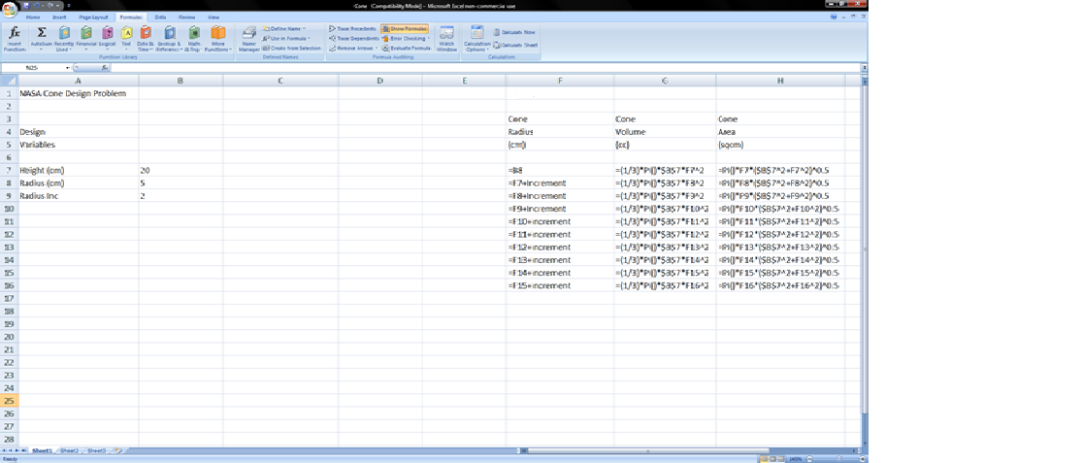

2-The Chart:
Another important tool in Excel is that of charts. We are interested in the plotting of the
Volume and Area as a function of the various radius values.
To do this, insert “Scatter with smooth lines and Markers” chart from the “Scatter” tab in the “Insert” menu. Now click on “Select Data” button and choose the cells between F3 to H16 obtaining the following:

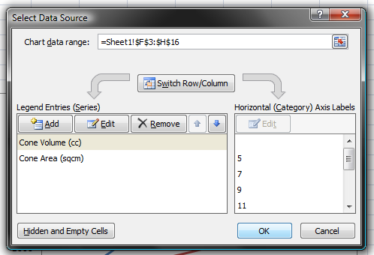

To label each axis, we click on “Axis Titles” in “Layout” menu of the chart tools. We can also use tools like “legend” and “chart title” for labeling.

VI- Results:

- After performing the above tasks the chart will look similar to what follows:

- And the overall spreadsheet will looks as the following:
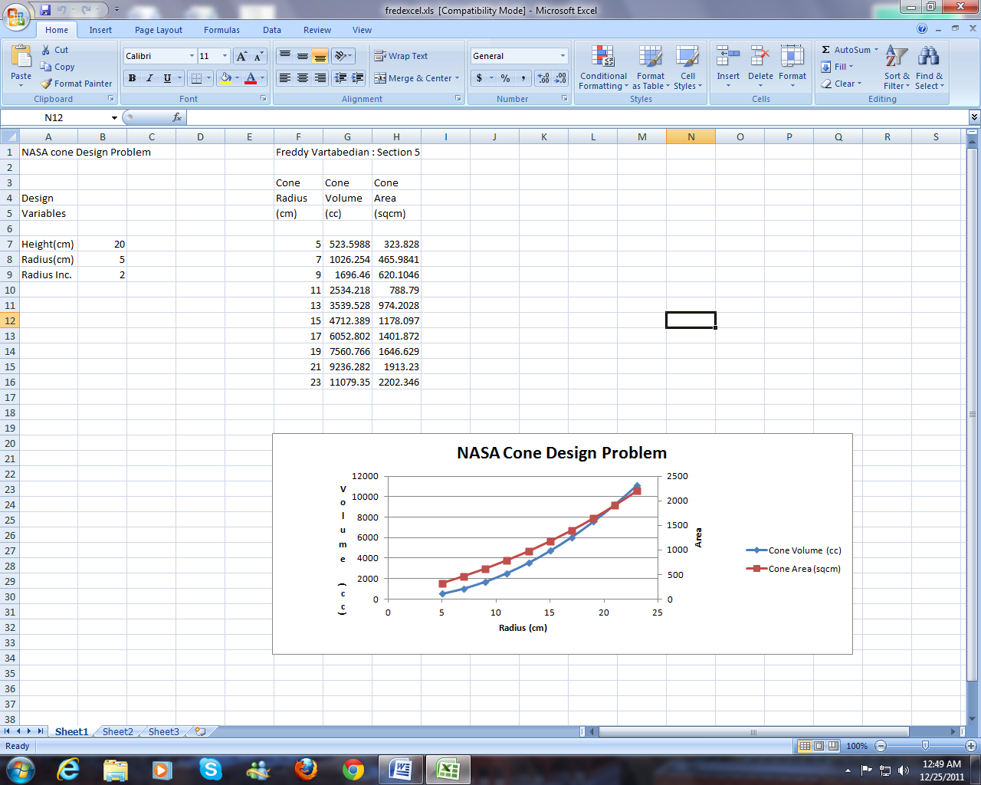

Results Discussion:
- The chart reveals that the volume and surface area of a cone are exponential in growth.

- It also shows the radius in which the volume is equal to the area, which is where the two curves in the graph intersect.

- One more important result is the ability to determine graphically the Volume or
Area for any other value of radius, without using any additional calculations.

VII-Conclusion
Excel gave us a simple way to calculate the volume and the area of a cone and conclude from the results that they both vary with the radius, in addition to the curves (graphs) that describe this variation.

VIII-References:
-Basic Tasks in Excel 2010, 2010.Office.microsoft.com/…/excel…/basic-tasks-in-201…-
United States.
-Introduction to Cone, www.emathzone.com>Geometry.
-Introduction to Microsoft Excel Part I: Basics,
www.qec.edu.sa/eng/.../Part%20I- Introduction%20to%20Excel.pdf
-Thomas G., Thomas Calculus, Ed.Deidre Lynch.12th ed.United States: Pearson,
2010.

Appendix: Excel Help
Microsoft Excel Help can help familiarize the user with the basic features of Excel and can guide him through the various features and tools.

